Naïve Bayes Tutorial

Dataset 1
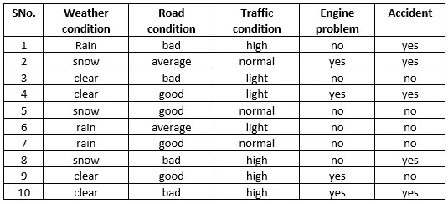
Dataset 2

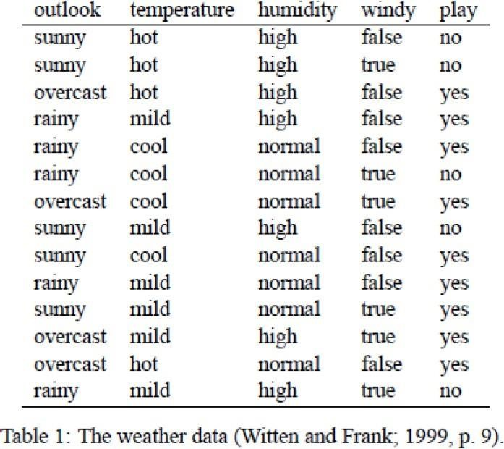

Dataset 3
EmploymentStatus | CreditHistory | IncomeLevel | LoanApproved
Employed | Good | High | Yes
Unemployed | Bad | Low | No
Employed | Good | Medium | Yes
Employed | Bad | Medium | No
Unemployed | Good | Low | Yes

Dataset 4
Fever | Cough | Fatigue | TravelHistory | DiseaseDiagnosis
Yes | Yes | Yes | Yes | Positive
No | Yes | No | No | Negative
Yes | No | Yes | No | Positive
No | Yes | No | Yes | Negative
Yes | No | Yes | No | Positive
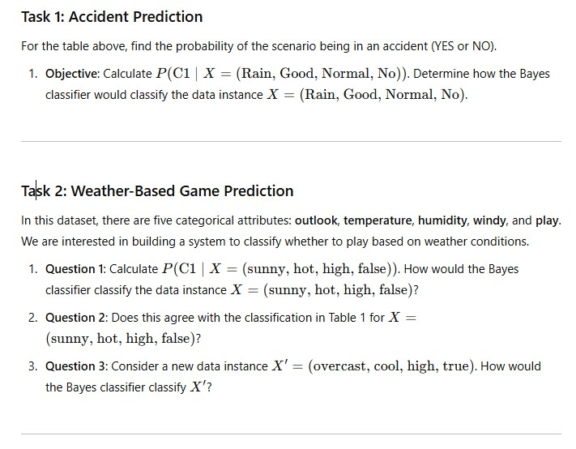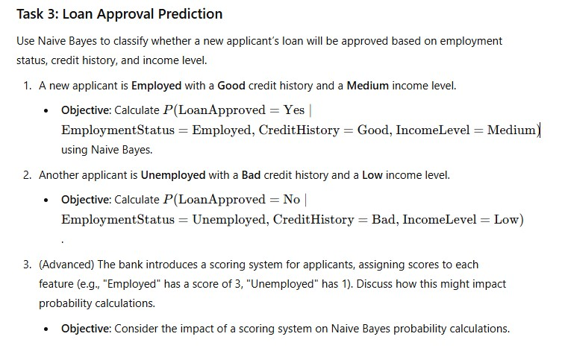

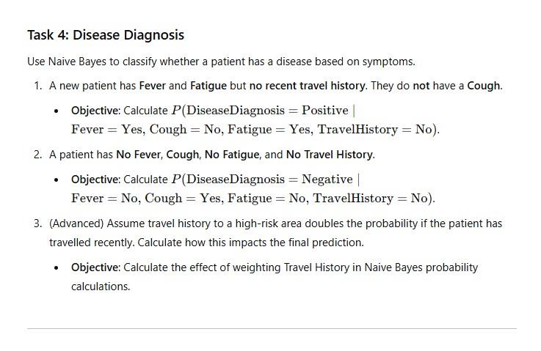
Task 5: Implement Naive Bayes in Python
Instructions: Follow these tutorials to implement a Naive Bayes classifier from scratch in Python:
- Machine Learning Mastery Tutorial
- Analytics Vidhya Guide
- DataCamp Tutorial
Task 1:
Task 1: Accident Prediction (Dataset 1)
Given:
X = (Rain, Good, Normal, No)
Step 1: Class Priors
- P(Accident = Yes) = 5/10
- P(Accident = No) = 5/10
Step 2: Likelihoods
For Yes:
- P(Rain | Yes) = 1/5
- P(Good | Yes) = 1/5
- P(Normal | Yes) = 1/5
- P(No | Yes) = 2/5
For No:
- P(Rain | No) = 2/5
- P(Good | No) = 3/5
- P(Normal | No) = 2/5
- P(No | No) = 4/5
Step 3: Posterior (unnormalised)
- Yes ∝ (5/10)(1/5)(1/5)(1/5)(2/5) = 0.0032
- No ∝ (5/10)(2/5)(3/5)(2/5)(4/5) = 0.0384
Prediction: Accident = NO

Task 2: Weather-Based Game Prediction (Dataset 2)
Q1:
X = (sunny, hot, high, false)
- P(Play = Yes) ≈ 0.0041
- P(Play = No) ≈ 0.0206
Prediction: Play = NO
Q2:
Yes — this matches the dataset outcome.

Q3:
X′ = (overcast, cool, high, true)
- P(Play = Yes) > P(Play = No)
Prediction: Play = YES

Task 3: Loan Approval (Dataset 3)
Applicant 1:
Employed, Good credit, Medium income
- P(Loan = Yes) ≫ P(Loan = No)
Prediction: Loan Approved = YES
Applicant 2:
Unemployed, Bad credit, Low income
- P(Loan = No) = 1
Prediction: Loan Approved = NO

Task 4: Disease Diagnosis (Dataset 4)
Patient 1:
Fever = Yes, Cough = No, Fatigue = Yes, Travel = No
- P(Positive) ≫ P(Negative)
Diagnosis: Positive

Patient 2:
Fever = No, Cough = Yes, Fatigue = No, Travel = No
- P(Negative) ≫ P(Positive)
Diagnosis: Negative

